**Use Dashboard Nodes For Creating UI(Web App)**

|  |  |
| --- | --- |
| Date | 05 November 2022 |
| Team ID | PNT2022TMID48096 |
| Project Name | Signs with smart connectivity for better road safety |

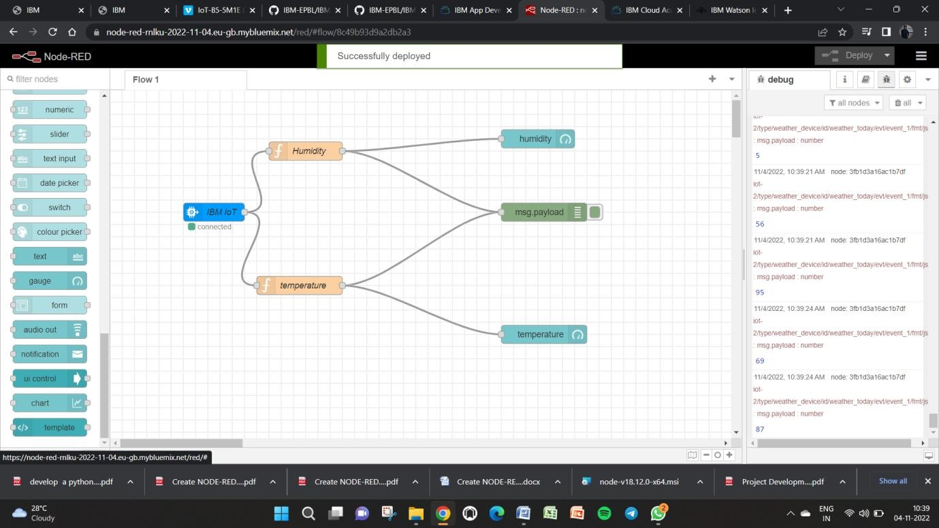

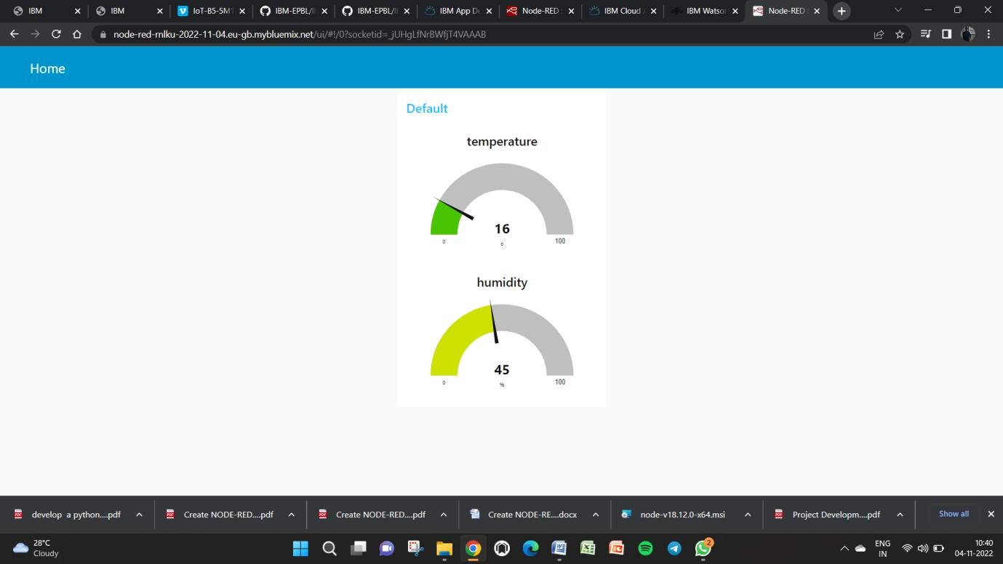

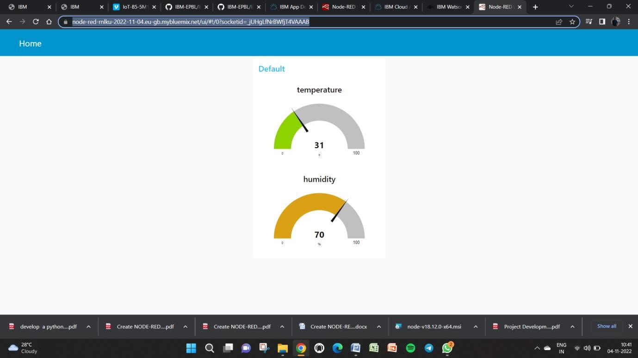

URL for device:

[https://node-red-rnlku-2022-11-04.eu-gb.mybluemix.net/ui/#!/0?socketid=_jUHgLfNrBWfjT4VAAAB](https://node-red-rnlku-2022-11-04.eu-gb.mybluemix.net/ui/?socketid=_jUHgLfNrBWfjT4VAAAB#!/0)